

SAMYAK-25

Event Information

Date:10.10.2025

Department Name

: CSE-3

Event Name

: UI Bug Hunt

Event Date(s)

:10.10.2025

Event Duration (Hrs./Days)

:4Hrs

Event Venue / Room No.

: C507

Resource Person Name

: M. Sudha Ramya

Designation & Address of Resource Person

:Student

Faculty Coordinator EMP.ID

: 9171

Faculty Coordinator Name

: Dr. THUMMALA PURNIMA

Faculty Coordinator Email-ID

: tummalapurnima@kluniversity.in

Description of the Event

:

A UI Bug Hunt is the process of finding and reporting visual or functional issues in an application's interface.
It ensures the app looks consistent, works smoothly, and offers a better user experience.

Page 2 of 9



Geotagged Photographs of the event

ROUND 1

Participants explored the application to identify visual and functional UI bugs such as alignment errors, color mismatches, and navigation issues.

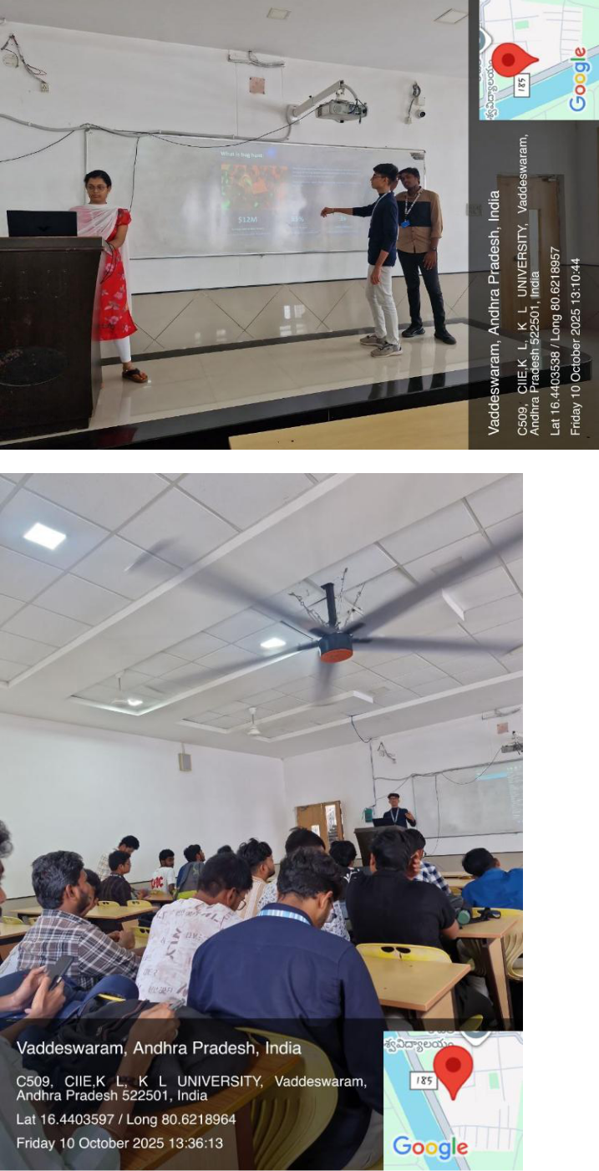

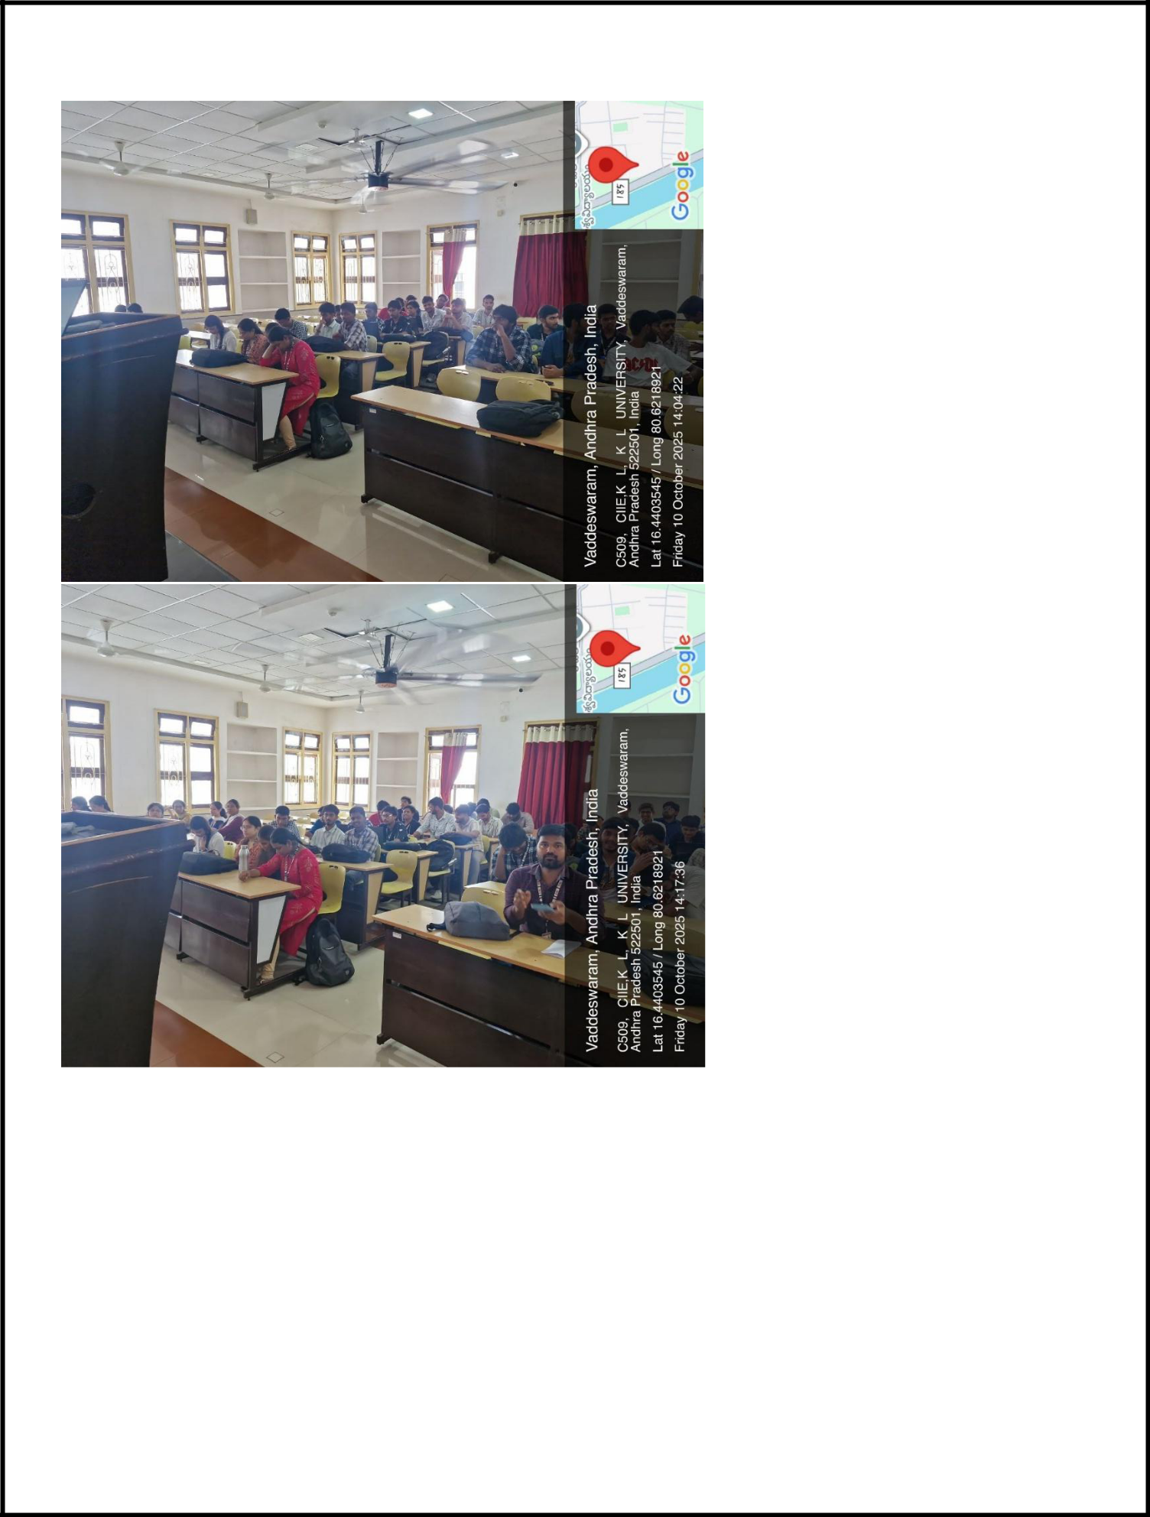

Page 4 of 9
Output :

During the UI Bug Hunt, various issues such as misaligned buttons, overlapping text, inconsistent font sizes, and color contrast problems were identified. These bugs can negatively affect user experience and accessibility. Fixing these issues improves the overall look and feel of the application, ensuring it is visually consistent, user-friendly, and professional.

ROUND-2

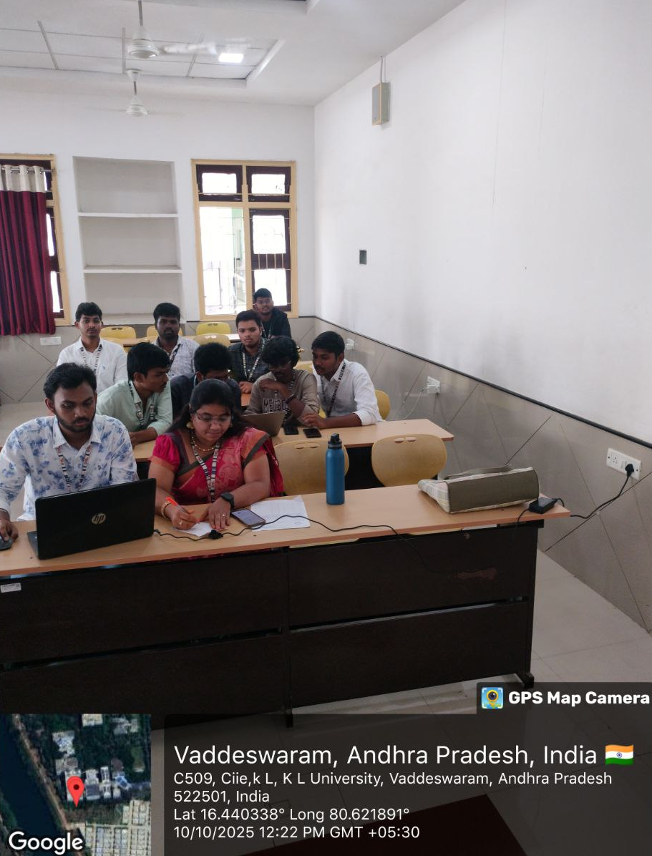
Shortlisted participants re-tested the app after fixes, verified resolved bugs, and suggested final improvements for better usability and design consistency.

EVENT POSTER:


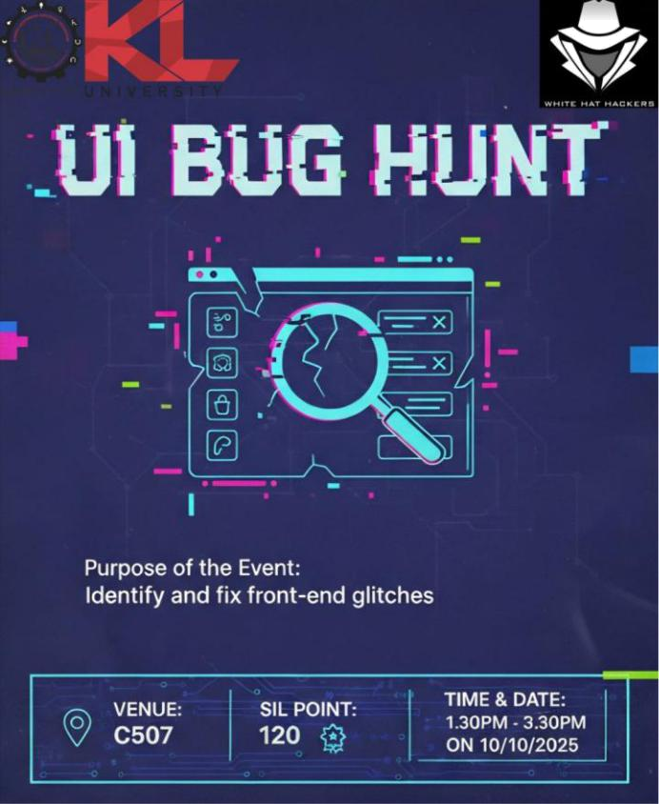

Signature of Faculty Coordinator

Signature of HOD

Signature of Convener
SAMYAK-25

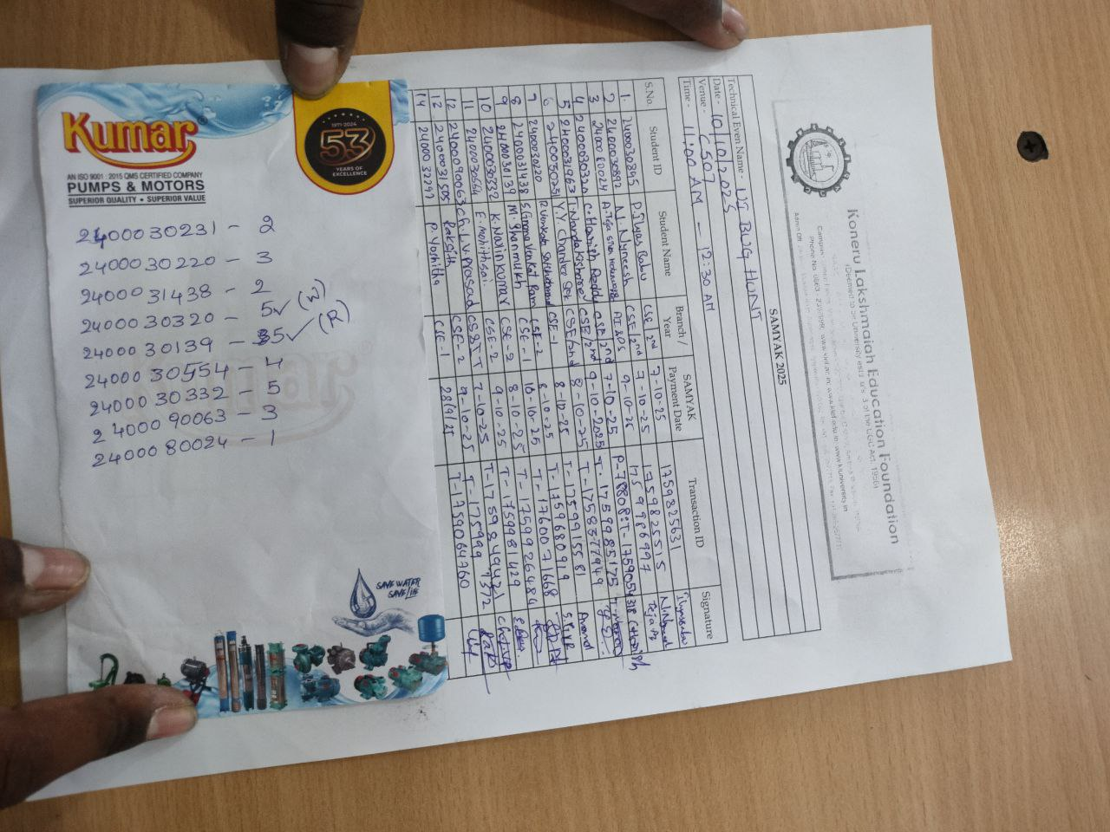
Page 6 of 6

